University of the Third Age Moseley Group at Kings Heath 18.12.2014
Moseley and Kings Heath Journal February 1920
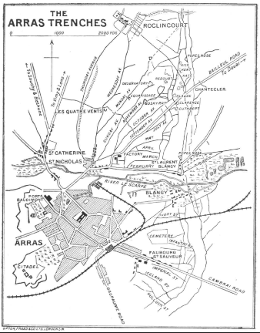
On 15 March 1916 the battalion began the second tour on the Arras front in the K2 sector near Rolincourt. The snow had cleared and there was a spell of warm weather during this period so that the battalion experienced dry trenches for the first time since arriving in France. When the front line trenches were taken over on 22 March, it was found that No Man’s Land was roughly fifty yards wide and in some part as little as thirty yards. Agnez les Duisans, was the rest village out of the line. The first few days were spent cleaning uniforms and polishing buttons. On 30 March the battalion lined the roads of the village as a guard of honour for a visit by Sir Douglas Haig but, instead of inspecting the battalion as planned, he and his entourage drove through the village at 3 pm without stopping. The battalion returned to the trenches on 4 April in support for 7 days and then moved into the front line for a further 9 days. During the period of support some of the men were attached to the Royal Engineers for mining duty. The battalion came out of the line on 21 April (Good Friday). 3 men had been killed and 6 wounded. 28 April they were back in the support lines. They moved into the front line on 4 May. On 7 May the battalion received its heaviest bombardment since its arrival in France. The bombardment started at 9.30 am and increased with intensity between 2.30 pm to 3.30 pm. It finally ceased around 6.30 pm. Apart from the sentries most of the men were safe in the deep dugouts; a thankful legacy from the former French occupiers of the divisional front. It was estimated that 2,000 shells passed over the battalion front. 1 man was killed and 20 wounded. During the next two days and nights the Germans continued to bombard the area with shell and shrapnel to deter working parties repairing the damage received. The battalion returned to Agnez de Duisans on 12 May and then to the front on 17 May. Both sides had been digging mines and planned to blow them on 19 May. The Germans won the race and blew theirs first at 4.30 am. Despite heavy German fire the battalion managed to occupy the crater. On 22 May D Company took part in a trench raid. The raid was a failure with many casualties. On the last day of May, the War Diary recorded that the strength of the battalion was 943, nearly 100 below strength. June started with trench mortar and artillery bombardments resulting in 2 killed and 4 wounded. Sunday 4 June 1916 was the last day of the present spell of front line duty. The weather was glorious and the front line was very quiet. Most thoughts would be on being relieved that evening and spending the next few days resting and cleaning up. At 4 pm the Germans started a concentrated bombardment which lasted for three hours and then stopped as suddenly as it began. There was massive devastation with both the front line and communication trenches hit with many casualties. When the survivors went back to the front line it was found to be a series of holes with no trenches remaining with dead and wounded soldiers lying around. The sentry shelter in the crater had taken a direct hit and was buried with a great deal of earth. One man was lying dead in the doorway. The earth was dug away and two men were found dead. One of them was Oswald Baker. At 9 pm the shelling began again with the same ferocity and then, 15 minutes later, the Germans exploded 3 mines with 2 exploding in front of the lines and the third under C Company’s front line. Then the Germans shelled the communication trenches with shrapnel and gas shells hitting the KOSBs who were coming up to relieve the 15th and killing 30 men. Fortunately the wind was westerly and so the gas had limited effect. The Germans then began an attack with 600 men to be driven off my intense rifle and machine gun fire. The battalion left the front line in the early hours of the morning. Total casualties for the 15th were officers killed 3; other ranks 63; dow 4; officers wounded 2; other ranks wounded 25; other ranks shell shocked 8; other ranks pow 9. Total 114
- Private Oswald Ernest Baker – 1584 15th Battalion (Second Pals Battalion), ‘A’ Company, Royal Warwickshire Regiment. He was the son of George and Hannah Sophia Baker. In 1911 they were living in 104, Melton Road, King's Heath, Birmingham. He was a clerk at a Coal Merchants. He was born in Redditch. He died on 4th June 1916 and is buried in the Faubourg D'Amiens Cemetery, Arras.
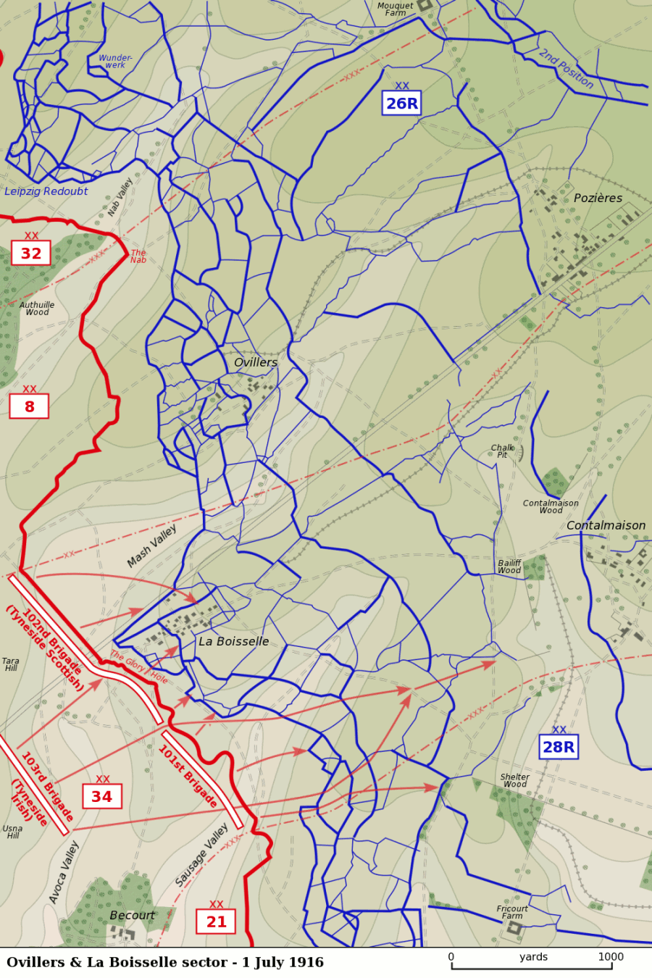 10th (Service) Battalion, Worcestershire Regiment was raised at Worcester in as part of Kitchener's Second New Army and joined 57th Brigade in 19th (Western) Division. They trained at Perham Down and in March 1915 moved to Tidworth for final training. They proceeded to France on the 18th of July 1915, the division concentrating near St Omer. Their first action was at Pietre, in a diversionary action supporting the Battle of Loos. In 1916 they were in action during the Battle of the Somme, capturing La Boisselle during the Battle of Albert. On 1 July 1916 La Boisselle was attacked by the 34th Division of III Corps but the bombardment had not damaged the German deep-mined dug outs(minierte stollen) and a German listening post overheard a British telephone conversation, which gave away the attack to be made the next day. The III Corps divisions lost more than 11,000 casualties and had failed to capture La Boisselle or Ovillers, gaining only small footholds near the boundary with XV Corps to the south and at Schwabenhöhe after the Lochnagar mine explosion had destroyed some of the defences of Reserve Infantry Regiment 110 had been destroyed. No German casualties were reported after the Y Sap mine detonation, as the defences nearby had been evacuated. The task of III Corps was made difficult by the topography of the area, since behind the British front there was no cover and that even small bodies of troops moving in daylight would attract massed machine-gun and artillery fire. La Boisselle and Ovillers across the road, had been fortified and entrenched, further north the Nordwerk and the Leipzig Salient in the X Corps area dominated the left of the III Corps sector, which left the attackers dependent on the effectiveness of the X Corps bombardment.

No man's land in the 34th Division sector varied from 200–800 yards (180–730 m) and as the preliminary bombardment was fired, it was seen that the German infantry in the front line was still able to observe the British front line and fire on parties in no man's land. The 34th Division plan of attack committed all of the infantry battalions, which left no immediate reserve. The mines had been expected to provide some protection against German machine-gun fire, by creating mounds around the crater rims and a smoke screen was to cover La Boisselle at zero hour but the wind blew it away from the village. The heavy artillery lifted off the German front line at 7:00 a.m., thirty minutes before the infantry advance, which meant that its fire for the rest of the day was ineffective.
The advance of the 103rd Brigade was over ground with a fold, which meant that the disastrous attack by the preceding brigades could not be seen as the brigade was hit by artillery and machine-gun fire, which inflicted 70% casualties before the troops had reached the British front line. The attack had gained a "derisory" amount of ground and the 19th Division was rushed forward, in case of a German counter-attack on Albert. The III Corps planning had been unimaginative but the failure of the artillery bombardment would have doomed any plan. The bombardment had been spread over too wide an area, against too many targets, which left the German front line garrisons mostly intact at zero hour, easily capable of defeating the attack. The 34th Division was relieved by the 19th (Western) Division opposite La Boisselle, which continued the attack and captured most of the village by 4 July
- Second Lieutenant Cyril Hadley – 10th Battalion Worcestershire Regiment. He was born on 30th May 1896. He was the son of Frederic and Ellen Louisa Hadley, of "Oakfield," Blenheim Road, Moseley, Birmingham. The house had 16 rooms and the family had a servant. His father was a managing director of an iron founding company. He was admitted to King Edward’s School in January 1907 and was later elected as a Foundation Scholar. Three of Cyril’s brothers, Edgar, Edward and Geoffrey, were also Old Edwardians and served during the war. At School, Cyril was an able modern linguist, but does not appear in the School magazines, suggesting that he was not an outstanding sportsman. In September 1914, Cyril enlisted in the Royal Engineers as a Sapper, and served in both France and Flanders. In September 1915, he gained a commission as a Second Lieutenant, attached to the 10th Worcestershire Regiment in France. He was wounded and declared missing, presumed killed, at Albert on 1st July 1916, aged twenty. He is commemorated on the Thiepval Memorial and on St Mary’s Church Memorial, Moseley. His father requested his son’s medals in 1921. He died on the 3rd July 1916 aged 20 and is remembered on the Thiepval Memorial.
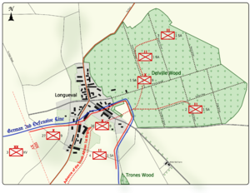 The 27 July at 7.10 am saw the resumption upon Longueval and Delville Wood with a bombardment beginning an hour previously. A creeping barrage was used for the first time moving forward at three intervals of 90 minutes. The infantry was then to rush forward and consolidate each time until the village and wood were cleared. Under the ruins of Longueval were a honeycomb of tunnels connecting many fortified cellars which gave the German defenders ample protection and so they came out and repelled the attackers with machinegun fire. At 8.15 the 16th Royal Wariwcks were ordered up in support. At 5.30 pm the 16th were ordered to form a defensive flank running from Longueval Church to the northern end of Trones Wood. At 19.10 they were ordered into the battle. 5 runners were sent back with a message to establish a strongpoint with Lewis guns but each runner was killed. They remained in the firing zone until the early hours of the morning when they moved back to the Pommiers Redoubt.

- Private Frank Harold Wheeler – 1197 ‘C’ Company 16th Battalion Royal Warwickshire Regiment. He was the only son of John Francis and Henrietta Wheeler of 32 Clarence Road, Moseley. In 1911 his father was a clerk for a Chartered Accountant. Frank’s three sisters were living with him. Frank was 16 years of age and was still at school. He died aged 21 on 27th July 1916 and is remembered on the Thiepval Memorial.

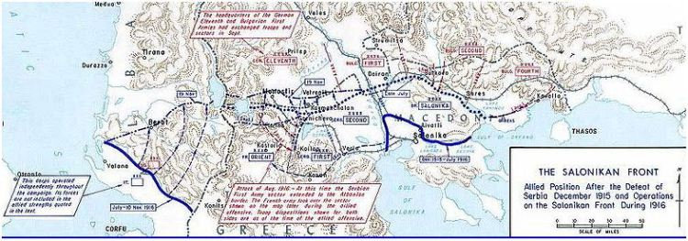 In the beginning of August 1916 three French and one British divisions with 45,000 men and 400 guns launched an offensive against the Bulgarian positions at Lake Dojran, defended by the Second Thracian Infantry Division. The attack began on 9 August with heavy artillery fire on the positions of the 27th Chepino Regiment and 9th Plovdiv Regiment. All four attacks that followed - on 10, 15, 16 and 18 August were repulsed by the Second division and the Allies were forced to retreat to their original positions with heavy casualties. Other sources state that the French took Tortoise Hill (Tortue) and Doldzeli, in total 30 square km, but at a very high cost. The British 7th Battalion of the Oxfordshire & Buckinghamshire Light Infantry took Horseshoe Hill.
More detail….The information obtained by Captain Leicester’s patrol (He found that the hill was not held in strength, and that the enemy’s defences were weak and much damaged by gun fire) enabled plans to be made for an attack on "Horseshoe Hill" on the following night. The attack would be made by the reserve battalion of the 78th Brigade, the 7th Oxford and Bucks L.I. To support the left flank of the attack the 11th Worcestershire would establish a post further forward on a knoll in the valley below.
The operation was commenced at 8.0 p.m. Two platoons of the 11th Worcestershire seized and entrenched the required knoll without opposition or casualties. Away to the right front the 7th Oxford and Bucks L.I., after a long night advance, stormed "Horseshoe Hill" at 2.30 a.m. (August 18th) and entrenched the captured position. The enemy made some attempts at counterattack next day; but they were beaten back and the gains were secured. The post established in the valley by the 11th Worcestershire was named "Worcester Post."
- Private Harry Davis – 15047 7th Battalion Duke of Edinburgh's (Wiltshire) Regiment (Formerly 15256, Oxfordshire and Buckinghamshire Light Infantry). He was the son of George and Mary Ann Davis, of 126, High Street, King's Heath. He was born in Northfield. Birmingham He was killed in Salonika on 22nd August 1916 and is buried in Karasouli Military Cemetery.

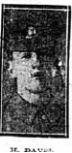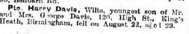
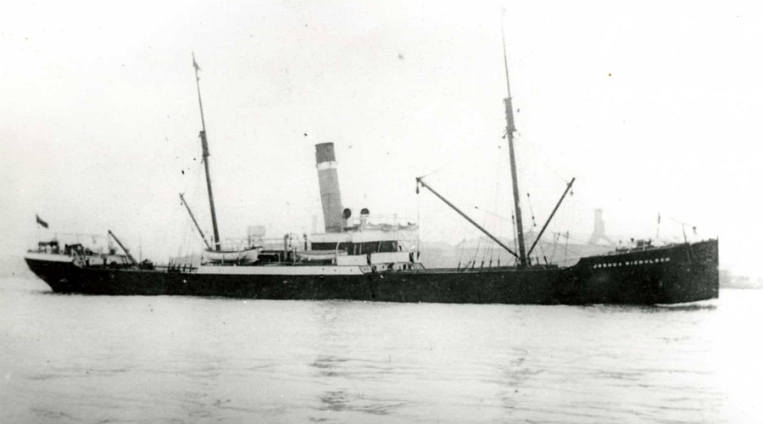
Joshua Nicholson SS was a 1,853grt defensively-armed British Merchant ship. On the 18th March 1917 when on route from London for Alexandria she was torpedoed by German submarine U-70 when off the Wolf Rock, Lands End, Cornwall. 26 lives lost including Master. Owned by Westcott & Laurance Ltd.
- Second Steward Cyril Harwood – Mercantile Marine S.S. "Joshua Nicholson" (North Shields) He was the son of Joseph and Harriet Harwood. His father was a carpenter and was born in Darwen, Lancashire. In 1911 he was living at 14 Heathfield Road, King’s Heath with his parents, 4 brothers and 1 sister. He died aged 17 on 18th March 1917 and is remembered on the Tower Hill Memorial.
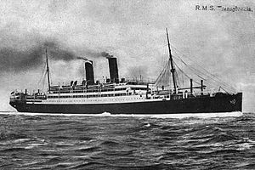
The SS Transylvania was a passenger liner of the Cunard subsidiary Anchor Line, and a sister ship to SS Tuscania. She was torpedoed and sunk on May 4, 1917 by the German U-boat U-63 at 44°15′N 8°30′ECoordinates: 44°15′N 8°30′E while carrying Allied troops to Egypt and sank with a loss of 412 lives.
Completed just before the outbreak of World War I, the Transylvania was taken over for service as a troopship upon completion. She was designed to accommodate 1,379 passengers but the Admiralty fixed her capacity at 200 officers and 2,860 men, besides crew, when she was commissioned in May 1915.
On May 3 1917, the Transylvania sailed from Marseille to Alexandria with a full complement of troops, escorted by the Japanese destroyers Matsu and Sakaki.
At 10 am on May 4 the Transylvania was struck in the port engine room by a torpedo fired by the German U-boat U-63 under the command of Otto Schultze. At the time the ship was about 2.5 miles (2.2 nmi; 4.0 km) south of Cape Vado near Savona, in the Gulf of Genoa. The Matsu came alongside the Transylvania and began to take on board troops while the Sakaki circled to force the submarine to remain submerged.
Twenty minutes later a second torpedo was seen coming straight for the Matsu, which saved herself by going astern at full speed. The torpedo hit the Transylvania instead, which sank immediately. Ten crew members, 29 army officers and 373 soldiers lost their lives.
Many bodies of victims were recovered at Savona and buried two days later, in a special plot in the town cemetery. Others are buried elsewhere in Italy, France, Monaco and Spain. Savona Town Cemetery contains 85 Commonwealth burials from the First World War, all but two of them casualties from the Transylvania. Within the cemetery is the Savona Memorial which commemorates a further 275 casualties who died when the Transylvania sank, but whose graves are unknown
- Private Alec Edward Parker – 66701 Royal Army Medical Corps. He born in Warwick and was the husband of D. Parker, of 36, Alcester Rd. South, King's Heath, Birmingham. In 1911 he was living as a boarder at 70 Vicarage Road, Kings Heath and his occupation was an insurance inspector. He died in this tragedy on 4th May 1917. He was 31 years of age and is remembered on the Savona Memorial
From 1915 until the end of the First World War 27th Field Ambulance in the Royal Army Medical Corps were attached to 9th (Scottish) Division. The Battle of Messines (7–14 June 1917) was an offensive conducted by the British Second Army, under the command of General Sir Herbert Plumer, on the Western Front near the village of Messines in Belgian West Flanders during the First World War. The Nivelle offensive in April and May had failed to achieve its more ambitious aims and this had resulted in the demoralisation of French troops and the dislocation of the Anglo-French strategy for 1917. The offensive at Messines forced the German Army to move reserves to Flanders from the Arras and Aisne fronts, which relieved pressure on the French Army. The tactical objective of the attack at Messines was to capture the German defences on the ridge, which ran from Ploegsteert ("Plugstreet") Wood in the south through Messines and Wytschaete to Mt. Sorrel, to deprive the German Fourth Army of the high ground south of Ypres. The ridge commanded the British defences and back areas further north, from which the British intended to conduct the "Northern Operation", to advance to Passchendaele Ridge, then capture the Belgian coast up to the Dutch frontier.
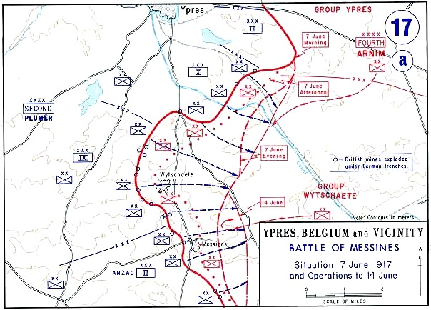
In the week before the attack, 2,230 guns and howitzers bombarded the German trenches, cut wire, destroyed strong-points and conducted counter-battery fire against 630 German artillery pieces, using 3,561,530 shells. The main bombardment began on 31 May, with only one day of poor weather before the attack. Two flights of each observation squadron concentrated on counter-battery observation and one became a "bombardment flight", working with particular artillery '"bombardment groups" for wire-cutting and trench-destruction; these flights became "contact-patrol flights" intended to observe the positions of British troops once the assault began. The attack barrage was rehearsed on 3 June to allow British air observers to plot masked German batteries, which mainly remained hidden but many minor flaws in the British barrage were reported. A repeat performance on 5 June induced a larger number of hidden German batteries to reveal themselves.
24,562: 1–12 June
- Lance Corporal John Browett Baker –3154 27th Field Ambulance Royal Army Medical Corps. He was the son of William Henry and Lizzie Baker. In 1911 he was at 7 Woodville Road, Kings Heath with his father William Henry Baker, a Railway Clerk, and sister, Emily, a shorthand typist. Later the family moved to 45, Hickman Road, Sparkbrook. He was a stretcher bearer. He died on the 3rd June 1917 aged 21 at Messines and is buried in the Athies Communal Cemetery Extension.
2nd Battalion, Royal Inniskilling Fusiliers were in Dover with 12th Brigade, 4th Division when war broke out in August 1914, they soon moved to Norfolk. 4th Division was held back from the original British Expeditionary Force by a last minute decision to defend England against a possible German landing. The fate of the BEF in France and the lack of any move by the Enemy to cross the channel, reversed this decision and they proceeded to France, landed at Le Havre on the 22nd of August 1914, arriving in time to provide infantry reinforcements at the Battle of Le Cateau, the Artillery, Engineers, Field Ambulances and mounted troops being still en-route at this time. They were in action at the The Battle of the Marne, The Battle of the Aisne and at Messines in 1914. On the 6th of December 1914 the Battalion became GHQ Troops, on the 26th of January 1915 they transferred to 5th Brigade in 2nd Division and saw action at The Battle of Festubert. On the 22nd of July 1915 they transferred as Army Troops to Third Army, then joined 14th Brigade, 5th Division on the 8th of November 1915. On the 24th of December 1915 the Battalion transferred to 96th Brigade, 32nd Division. In 1916 they were in action during the Battles of the Somme 1916, In 1917 they were involved in Operations on the Ancre and the pursuit of the German retreat to the Hindenburg Line.
12th May 1915 The 2nd Battalion Royal Inniskilling Fusiliers marched through Richebourg on their way up to the the line to preparr for their part in the Battle of Festubert.
1st Jan 1916 16th Northumberlands played the 2nd Battalio Royal Inniskillin Fusiliers in the intercopmany football matches. New Year's Day was a holiday and a special dinner took place.
30th Jun 1916 The 16th Battalion Northumberland Fusiliers moves to its battle position, via Martinsart, Aveluy wood and Black Horse Bridge. To relieve the 2nd Inniskillings at 2.30 am.
25th Aug 1916 The 16th Battalion Northumberland Fusiliers were relieved in the left sub-sector of the Cambrin sector, by the 2nd Battalion Royal Inniskilling Fusiliers. The Northumberlands retired to the village line, B coy leaves the garrison in Arthurs Keep.
29th Aug 1916 The 16th Battalion Northumberland Fusiliers relieve the 2nd Battalion Royal Inniskilling Fusiliers, in the left sub-sector of the Cambrin sector, resuming the routine of holding the line, rest and working parties for the next couple of weeks.
11th Mar 1917 The 16th Btn Northumberland Fusiliers relieve 2nd Btn Royal Inniskilling Fusiliers, on the extreme right of the divisional sector, the french are on right of battalion with the connecting point at the Amiens-Roye road.
15th Mar 1917 The 16th Btn Northumberland Fusiliers are relieved by the 2nd Btn Royal Inniskilling Fusiliers, on the extreme right of the divisional sector, up to the Amiens-Roye road, with French troops to their right.
31st Mar 1917 The 16th Btn Northumberland Fusiliers man the outpost line, with Battalion HQ at Germaine. A strong enemy rearguard party is located at Savy Wood and 96 brigade are ordered to clear it. The 2nd Inniskillings and 15th Lancashires attack with 16th Northumberlands in support.

1st Apr 1917 96th Brigade attack Savy Wood and capture their objectives, the 16th Northumberlands occupy the quarry for about one week, suffering fairly heavy casualties. 3 Officers wounded, 23 Other Ranks killed, 78 ORs wounded, and 5 ORs missing.
About the middle of May 1917, The 11th Lonsdale Battalion marched by way of Nesle, Corchy, Puzeaux and Caix to Domart-sur-la Luce. Here more training was undertaken until the end of the month, when the Battalion marched to Villers Bretonneux billets. Early on the morning of the 1st June 1917 the .' Lonsdales '' proceeded by train to Steenbecque via Abbeville, Etaples, Boulogne, Calais and Hazebrouck and detrained again at 4.00pm, marching to Neuf Berquin by Merville, arriving at 11.00pm. Here more training continued for the best part of a fortnight, then the Battalion marched and travelled by bus to the neighbourhood of Dunkirk via Caestre and Godwaerswelde. At the end of June 1917, the Battalion found itself in occupation of '' the ' C ' Sub-Sector '' of the Nieuport-Lombartzyde Sector, as part of British XV Corps( 1st , 32nd and 65th Divisions). In early July the sector was "very inactive apart from shelling". On the 4th July 1917, a trench raid was mounted by the Lonsdales at 11.24 p.m. they used a Bangalore Torpedo to clear the enemy wire, but met with a hail of bombs in front of the enemy lines and were forced to withdraw with 1 officer wounded and 2 men killed.
From June to November 1917, Commonwealth Forces (XV Corps) held the front line in Belgium from St.Georges (now Sint Joris), near Ramskapelle, to the sea. British units did not return to this sector of the Western Front until June 1917, when the 32nd Division relieved French troops stationed at Nieuport in preparation for planned Allied landings on German-held territory along the Belgian coast. German marines launched a pre-emptive attack against the British forces on the river Yser in July and the landings, codenamed ‘Operation Hush’, never took place. Over 260 men commemorated on the Nieuport Memorial were killed or mortally wounded during heavy fighting with units of the German Marine-Korps Flandern on July 10 1917.
Operation Hush
The Germans occupied most of the Belgian coast after the 'Race to the Sea' in 1914. The MarinesKorps Flandern was created by the German navy to protect the coast and to create naval bases. Antwerp could not be used for German naval operations but Ostend, Zeebrugge and Bruges were all used for submarine and surface raiders. German U-boats sank British ships with torpedo attacks and by laying mines. German A-class torpedo boats, along with G- and S- Class destroyers also harrassed British ports and the critical supply routes across the English Channel. In 1917 Admiral Sir Reginald Bacon proposed that an amphibious landing should be made on the Belgian coast, supported by a breakout attack from Nieuport and the Yser bridgehead. It was called Operation Hush. Planning for the landings began almost immediately. Three huge pontoons, each 700 feet long, were built to accommodate the landing forces, which included 13,750 men from the 1st Division, with supporting artillery, tanks, motor machine guns, cyclists and trench mortar batteries. Each pontoon was pushed along
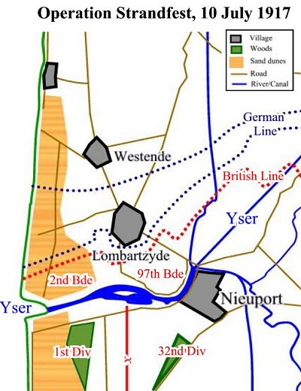

two monitors, which were also tasked with attacking shore positions during the landing. Aerial photographs and submarine sorties were used to map the profile of the beaches. This information was used to shape the hulls of the pontoons, so that they would slide easily up the beaches and get as close to the sea wall as possible. The whole landing was to be screened with smoke from eighty boats, each with three burners, and a total of fifty tons of phosphorus.
Training for the landings took place in great secrecy. Frank Mitchell, a tank driver who later won the MC in the first tank vs. tank battle in 1918, took part in training. "The [Belgian coast sea] wall had not been long built, and luckily the Belgian architect who had designed it was a refugee in France. When he was traced the military authorities found to their delight that he had his drawings with him, so a model was built in an isolated camp near Dunkirk, where the infantry patiently practised and re-practiced the assault. A similar concrete model was erected in the lonely sand dunes at Merlimont, and a detachment of tanks, manned by volunteers, set about the difficult task of climbing the wall"; The tanks were fitted with "special shoes on the tracks. The difficulty of the overhanging coping still remained. Many experiments were made by the engineers, and at last a solution was found. Each tank was fitted with a large steel ramp... When the tank reached the foot of the wall, the ramp was lowered by means of tackle until the wheels rested on the slope. The tank then trundled it up the incline and [then] after disengaging itself, was able to climb up over the ramp on to the esplanade".
The plan for Operation Hush became an integral part of the thinking that eventually took the form of the Third Battle of Ypres. This attack, which was eventually launched on 31 July 1917, was aimed initially at capturing and clearing the Belgian coast. Once forces had broken through the German defences at Ypres, the landings would take place.
On 22 May 1917, Sir Douglas Haig gave Sir Henry Rawlinson command of the coastal sector of operations. He placed his HQ at Malo-les-Bains near Dunkirk. XV Corps moved up from the Somme, to become the operational formation that would undertake the army's part of Operation Hush. On 20 June 1917, 32nd Division took over the Nieuport bridgehead from a French Corps. 1st and 66th (2nd East Lancashire) Divisions moved up before the end of June, and 49th (West Riding) and 33rd Divisions joined them by the end of July. These formations began intensive training in locations along the coast. In addition, 189 heavy guns moved up from Second and Third Army areas, as did IV Corps of the Royal Flying Corps, and a similar sized force of the Royal Naval Air Service.
The Germans were well prepared for a landing. The MarinesKorps Flandern, initially comprised two MarineDivisions, but a third MarineDivision was created on 1 July 1917. The MarinesKorps also included a Sturmabteilung of highly trained stormtroopers. It had built 24 coastal batteries, including eight large calibre naval gun batteries capable of engaging ships up to 30 kilometres off the coast. A line of trenches and wire extended along the coast, supported by 33 concete machine gun nests spaced every 1,000 metres. Mobile infantry and artillery reserves were available from 4th Army. War games were held to simulate invasions and the Germans felt confident they could contain any attempt.

The British chose Middelkerke as the site for the landings. This was the area that was least well defended and it was within easy reach of Nieuport. Despite the thorough preparations, the amphibious assault never went ahead. The expected gains from the Third Battle of Ypres never materialised. The MarinesKorps Flandern detected the British take-over of the Yser bridgehead and launched a pre-emptive attack (Operation Strandfest), depriving the British of their platform for a supporting attack along the coast. Hush was cancelled and no landing ever took place.
On the 20 June, the British XV Corps took over the French sector on the Belgian coast. The MarinesKorps Flandern patrols detected the changeover on the 21st. Korps commander von Schroeder correctly interpreted this report as the prelude to a British attack along the coast. He began planning Operation Strandfest, a pre-emptive strike to eliminate the Yser bridgehead. Meanwhile, the British set about improving the defences in the bridgehead. Tunnellers were used, including the 257th and the 2nd Australian Tunnelling Companies, but their work was not complete when Operation Strandfest began. Nor was all the British artillery in place; only 176 of the planned 583 guns and howitzers were available to defend the bridgehead.
On the 6 July 1917, the MarinesKorps Flandern began a desultory artillery bombardment, which continued for the next three days. Fog and low cloud prevented detection of the German build-up. Then, at 5.30am on the 10 July the massed German artillery, including three 24cm naval guns in shore batteries and 58 artillery batteries (planned naval gunfire support from destroyers and torpedo-boats was cancelled), opened up on the British positions in the bridgehead. Mustard gas (Yellow Cross) was used for the first time in the barrage. All but one of the bridges over the Yser River were demolished, isolating the 1/Northamptonshire and 2/KRRC of 2nd Brigade, 1st Division on the extreme left flank. Telephone communication was also cut. The German bombardment continued throughout the day. The British artillery attempted a counter-barrage but several guns were knocked out and the German infantry were well protected. At 8pm, the MarinesKorps launched the infantry assault, by which time the two British battalions had suffered 70-80% casualties. The German stormtroopers attacked down the coast, outflanking the British. Their attack was then followed by waves of German Marines, supported by flamethrower teams to mop up dugouts. After a gallant defence, the British battalions were overwhelmed. Only 4 officers and 64 other ranks managed to reach the west bank of the Yser.
The River Yser can be seen with Nieuport-Bains on the (left) bank. The North Sea coast is at the top of the map. The British front line is sketched in blue on the opposite bank, with the German front in red facing it. It was here that the 1st Northamptons and 2nd King's Royal Rifle Corps suffered such heavy casualties on 10 July 1917. The German attack on the 32nd Division, further to the east, was less successful. Only the 97th Brigade was attacked and although there was some penetration into the line, a counterattack that night by the 11/Border Regiment, supported by two companies of the 17/Highland Light Infantry, restored all but 500 yards of the front line. A general counterattack was ordered for the 11 July by General Rawlinson. Wisely, he later rescinded his decision at the request of XV Corps Commander, Lt. General John Du Cane. The total British casualties amounted to approximately 3,126 of all ranks, killed, wounded and missing. Of these, fifty officers and 1,253 other ranks belonged to the two battalions of 1st Division. Lieutenant Colonel Richard Abadie DSO, Officer Commanding 2/KRRC, has no known grave and is commemorated on the Nieuport Memorial to the Missing.
- Private Horace Shaw – 41434 2nd Battalion Royal Inniskilling Fusiliers. He was the son of Walter and Nellie Shaw. In 1911 the family were living at 20 Fairfield Road, Kings Heath. His father was a carriage lamp worker. Horace had 12 siblings but only six were living in 1911. He was 13 years of age and was still at school. He died of his wounds, aged 19, on 6th July 1917 and is buried in the Ramscappelle Road Military Cemetery.
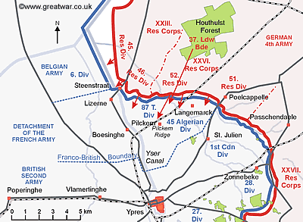
The Battle of Pilckem Ridge, 31 July – 2 August 1917, was the opening attack of the main part of the Third Battle of Ypres in the First World War. The battle took place in the Ypres Salient area of the Western Front. The Allied attack had mixed results; a substantial amount of ground was captured and a large number of casualties inflicted on the German defenders, except on the tactically vital Gheluvelt plateau on the right flank. The German defenders also recaptured some ground on the XIX Corps front, from the Ypres–Roulers railway, north to St. Julien. After several weeks of changeable weather, heavy rainfall began in the afternoon of 31 July and had a serious effect on operations in August, causing more problems for the British who were advancing into the area devastated by artillery fire and which was partly flooded. The battle became controversial, with disputes about the predictability of the August deluges and for its mixed results, which in much British writing were blamed on misunderstandings between Gough and Haig and on faulty planning, rather than on the resilience of the German defence.
- Private Arthur Anney – 35191 6th Battalion Royal Berkshire Regiment. He was the son of George Thomas Anney, a chocolate worker at Cadburys and Elizabeth, a provisions dealer. In 1911 they were living at 4 Heathfield Road, Kings Heath and Arthur was working in a Boot shop. He was 16 years of age and was born in South Wales. He had 2 brothers and 3 sisters. 7 other of his siblings had died. Later his family were living at 12, Grange Road, King's Heath. He died on 31st July 1917 aged 22 and is remembered on the Ypres (Menin Gate) Memorial
Attack on the Polderhoek Chateau – At 5.20 am on 9 October 1917 2 companies of the 1st Norfolks and three from the 16th Royal Warwickshire Regiment attacked behind a creeping barrage. The ground was in a pretty bad state with shell-holes full of water, the ground deep in mud and then men heavily laden with picks, shovels and sandbags. It took them two hours to cover 500 yards and all the time they were shelled. They bedded down in trenches and then continued the attack against the pill boxes surrounding the ruins of the chateau on the next day with fierce hand to hand fighting and counter-attacks. When they were relieved on 11 October with over 300 casualties, 94 killed and 10 dying later of their wounds.
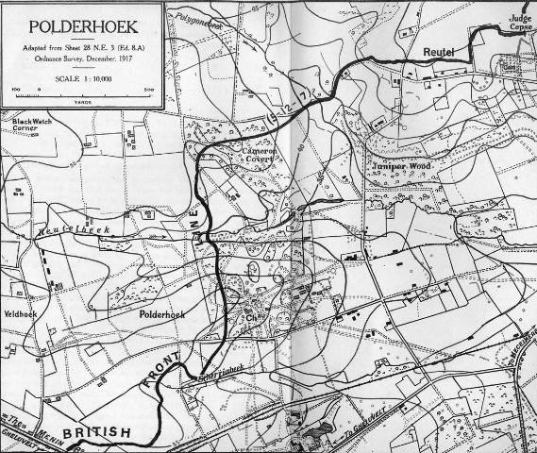
- Private Leonard Hayes – 22381 16th Battalion Royal Warwickshire Regiment. He was the son of Enoch James, and Ellen Hayes, of 6, Milford Place, High St., King's Heath, Birmingham. He died on 9th October 1917 aged 20 and is buried in the Hooge Crater Cemetery.
The 48th Divisional Train served with 48th (South Midland) Division, orginally known as the South Midland Divisional Transport and Supply Column. They mobilised for war service on 5 August 1914 and moved to concentrate in the Chelmsford area by the second week of August 1914 and commenced training. They proceeded to France in March 1915 with the Divisional HQ, the Gloucester & Worcester and South Midland Brigades embarking from Folkestone and sailing to Boulogne whilst the remainder sailed from Southampton to Le Havre. The Division had concentrated near Cassel. In 1916 the Division were in action in the Battle of the Somme, suffering heavy casualties on the 1st of July in assaulting the Quadrilateral (Heidenkopf). They were also in action at The Battle of Bazentin Ridge, capturing Ovillers, The Battle of Pozieres Ridge, The Battle of the Ancre Heights and The Battle of the Ancre. In 1917 the Division occupied Peronne during the The German Retreat to the Hindenburg Line and were in action in the Third Battles of Ypres. On the 21st of November 1917 they entrained for Italy. In 1918 they were involved in the fighting on the Asiago Plateau and The Battle of the Vittoria Veneto in the Val d'Assa area.
From April 1918 to the early months of 1919, the 9th, 24th and 39th Casualty Clearing Stations occupied the village school at Dueville and used the extension to the communal cemetery for the burial of those who died of wounds or disease. The Allied front on the Asiago Plateau was about 22 kilometres distant; the Piave front, to which the XIVth Corps was moved for the final attack on the Austrian positions in October 1918, was about 64 kilometres from the village.
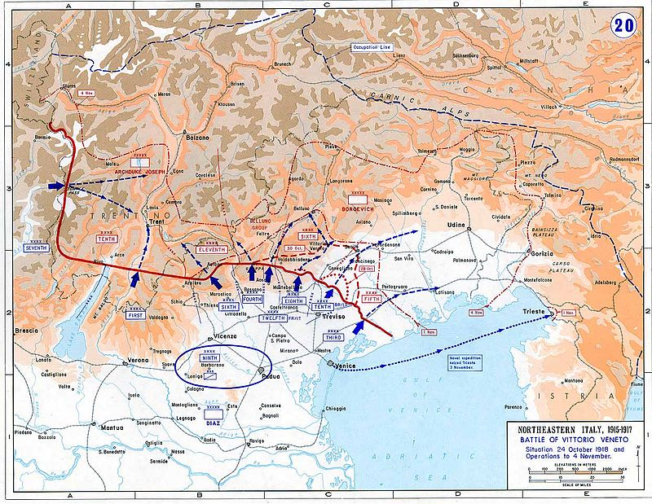
The Battle of Vittorio Veneto was fought from 24 October to 3 November 1918 near Vittorio Veneto during the Italian Front of World War I. The Italian victory marked the end of the war on the Italian Front, secured the dissolution of the Austro-Hungarian Empire and contributed to the ending of the First World War less than two weeks later. 36,498 dead, wounded, or missing (of whom 1,830 British and 588 French)
- Private Samuel Gould - M2/053149 48th Divisional Mechanical Transport Company Royal Army Service Corps. In 1911 he was living in his Brother-in-Law’s house (James WilliamOwen) at 42 Addison Road, King’s Heath. Living with him were his sister Selina, who was James’s wife, and her three children, his mother Emma and brother Ralph. He was a vanman at Cadburys. He died of his wounds on 14th January 1919 aged 29 and is buried in Dueville Communal Cemetery Extension.

